|  |  |
| --- | --- |
| Los pollos hermanos Logos  Information kiosk  IT PAT 2021 | About  Information kiosk for the restaurant Los Pollos Hermanos, which allows customers to view the menu, make an order and provides customers with all relevant contact information. Also allows managers to keep a record of all purchases made using the kiosk and manage the menu.  By Rohern Dhaya 11U |

Contents

Scenario and Scope 2

User Requirements 3

Navigation – Flow Chart 0

GUI – Design 0

Database 4

Tables, field types and field sizes 4

Data Dictionary 5

Text Files 5

Arrays 5

IPO Table 6

# Scenario and Scope

Imagine it is finally your turn to place your order after waiting in a long queue after a busy, hard day of work, and you’re absolutely starving, just itching to get home with your takeaway and enjoy a nice delicious supper just for the waiter to get your order wrong. Sounds like a nightmare, right? Well, with our automated information and self-ordering kiosk all of these problems will be alleviated. The main aim of this kiosk is to allow users to place their orders and find out any relevant information they might need as easily and efficiently as possible with little or no need for customer support. This will greatly reduce ordering times and will also help cut down on labor costs. As a manager or owner, you will have access to a record of all purchases made via this kiosk and also have full customization over your menu and all relevant information.

# User Requirements

|  |  |  |
| --- | --- | --- |
| **User Requirements** | | |
| **Users** | **Customer** | **Manager** |
| **User needs** | Have the ability to view the menu, place orders and view other relevant details such as contact details, other branches etc. | Have the ability to edit the menu and other details on the kiosk such as contact details, add new branches etc. |
| **Acceptable limitations** | Customers will only be able to place orders and view other information. | Managers won’t be able to customize the general look of the kiosk. |
| **Processing requirements** | N/A | 64-bit Architecture  Minimum system memory: 4 GB  Minimum available hard drive space: 10 GB  Minimum CPU architecture: 4 cores  Operating System (64-bit only)   * Windows 7 Requires Service Pack 1 and Microsoft updates KB2533623 and KB3033929 * Windows 8 * Windows 8.1 * Windows 10 * Windows 2008 R2 * Windows 2012 / 2012 R2 * Windows 2016 * Windows Installer - 4.5 or higher |

# Navigation – Flow Chart

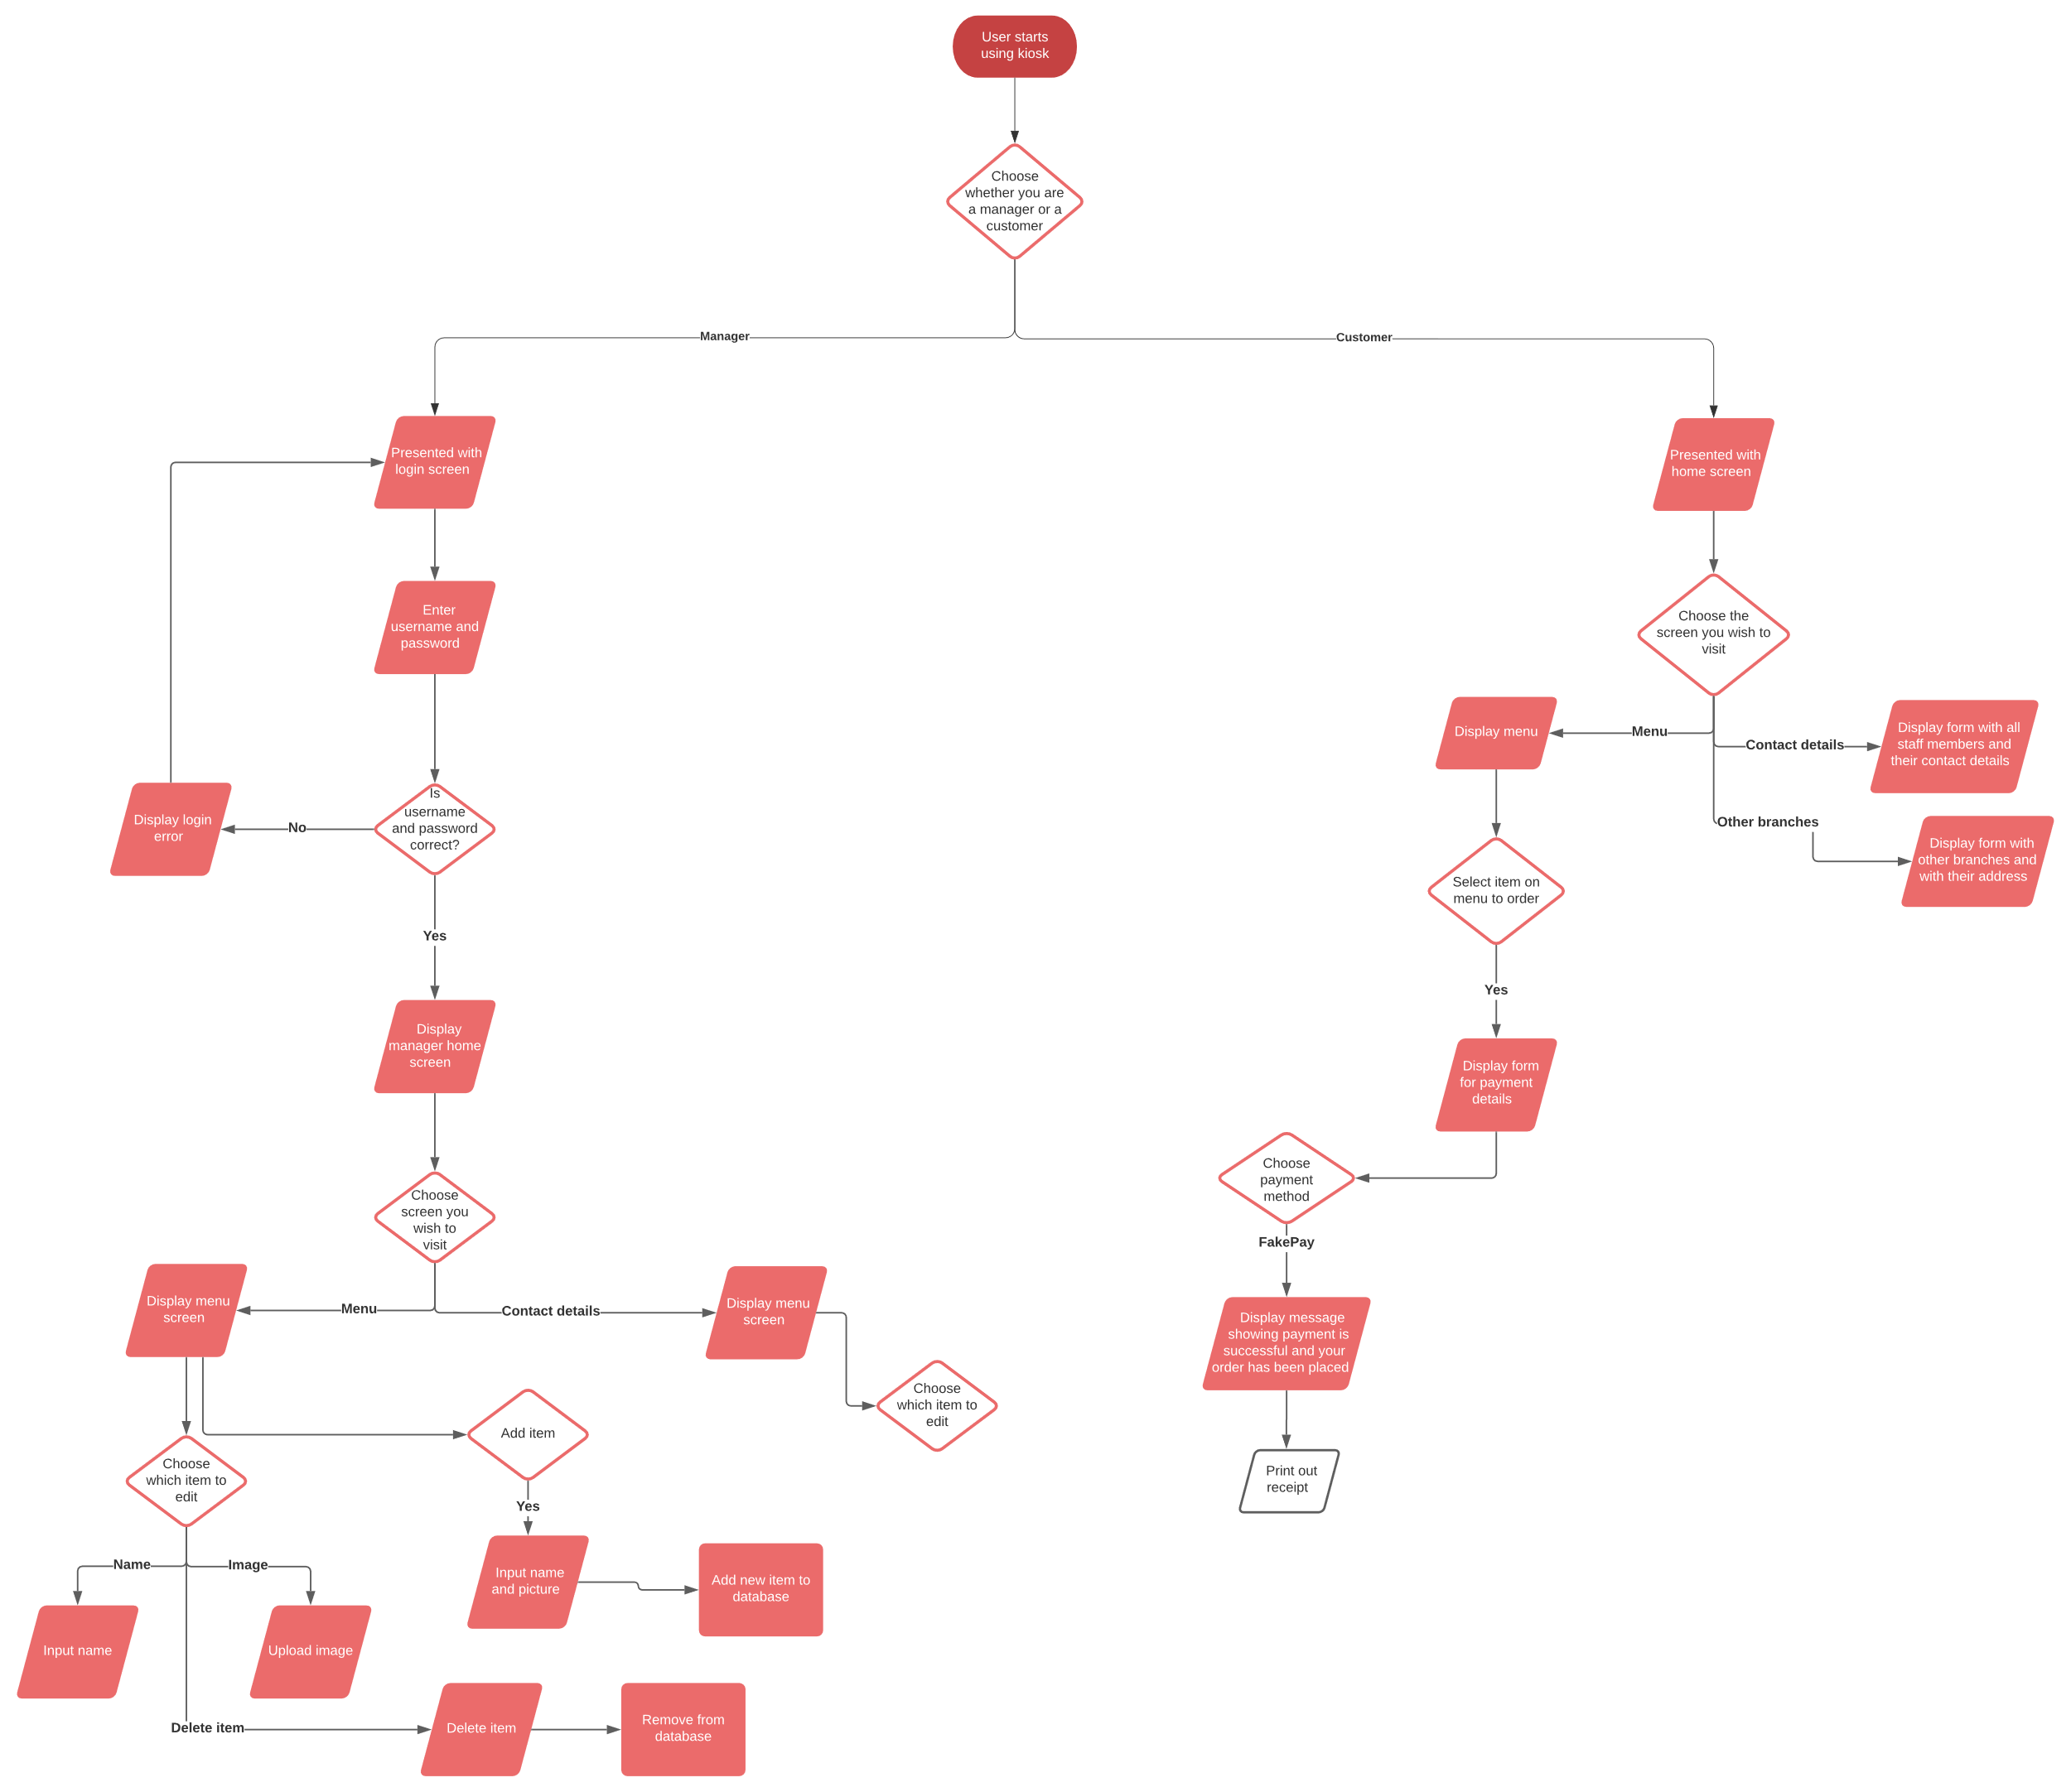

# GUI – Design

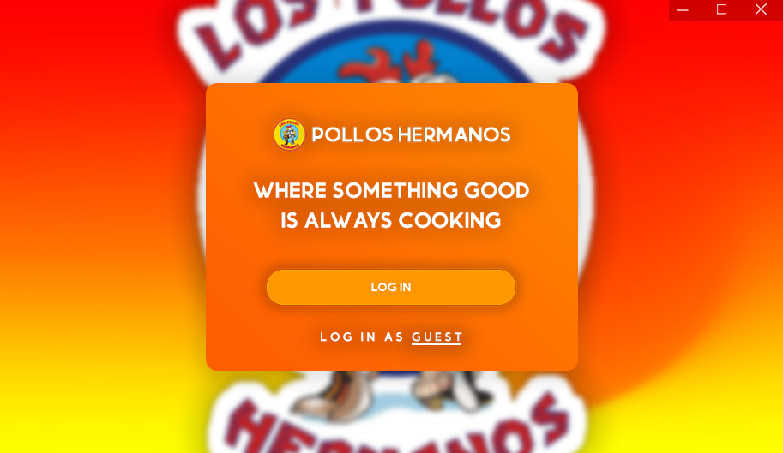

Figure 1 - Welcome screen

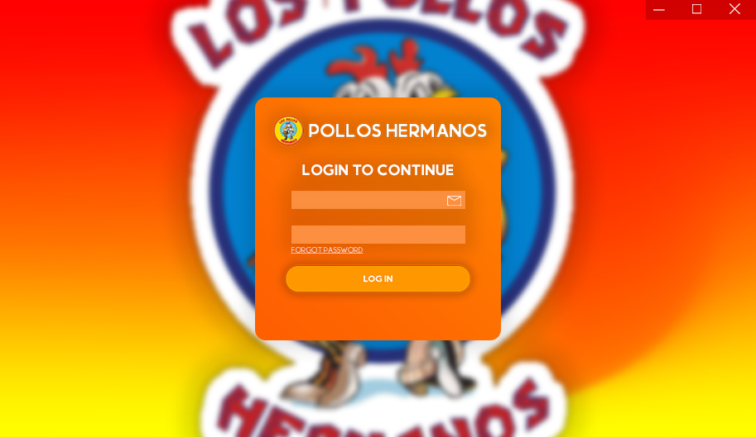

Figure 2 - Login Screen

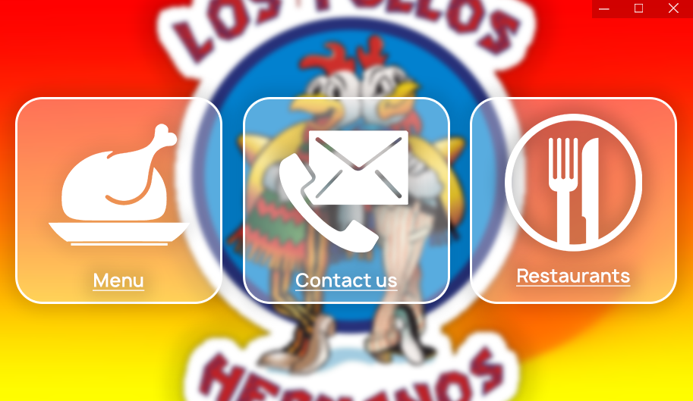

Figure 3 – Home screen

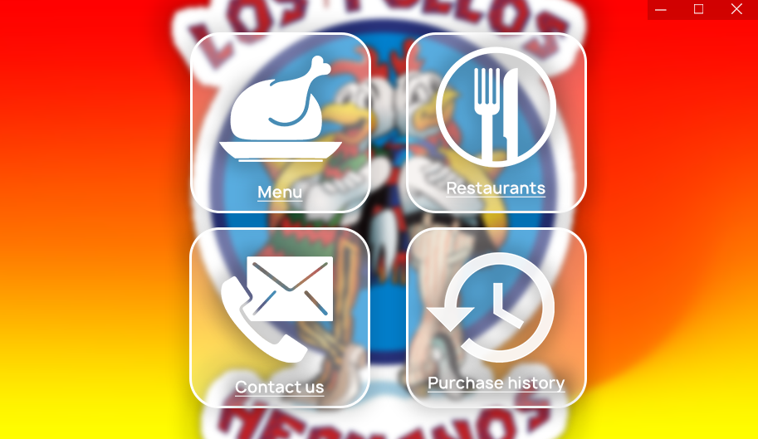

Figure 3.1 - Home screen (management)

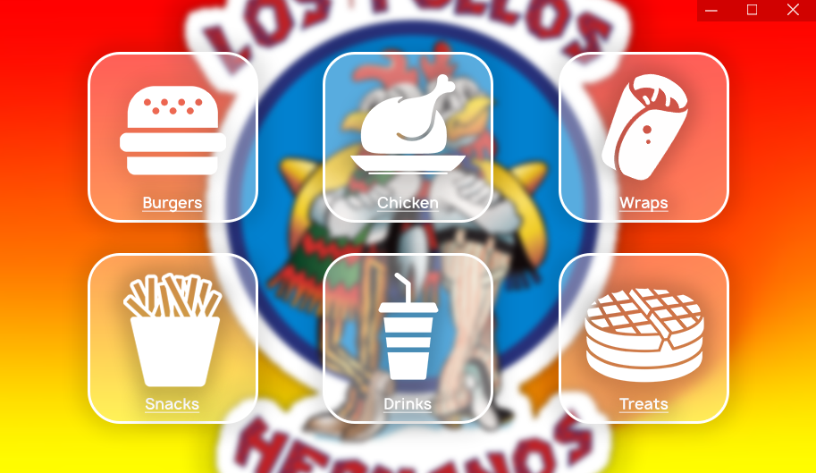

Figure 4 - Menu screen

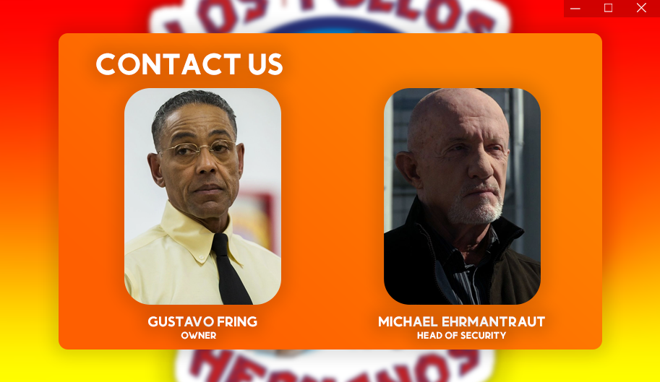

Figure 5 – Contact us screen

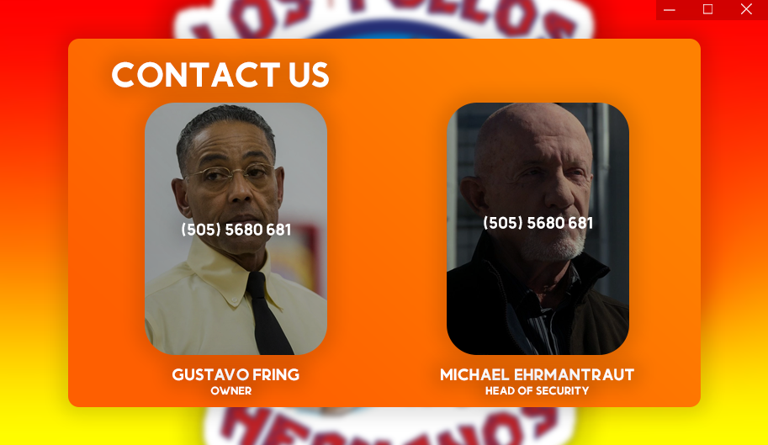

Figure 5.1 - Contact us screen (details)

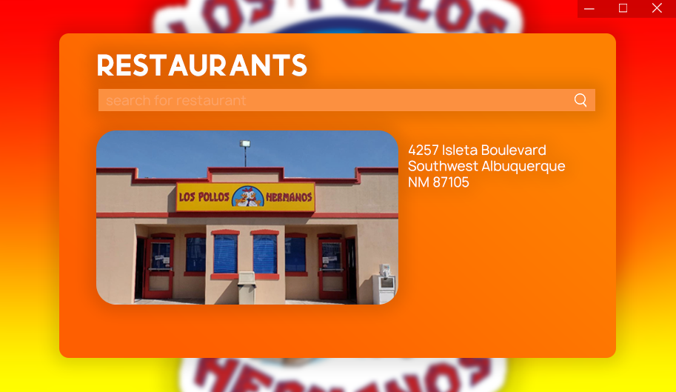

Figure 6 - Restaurant search screen

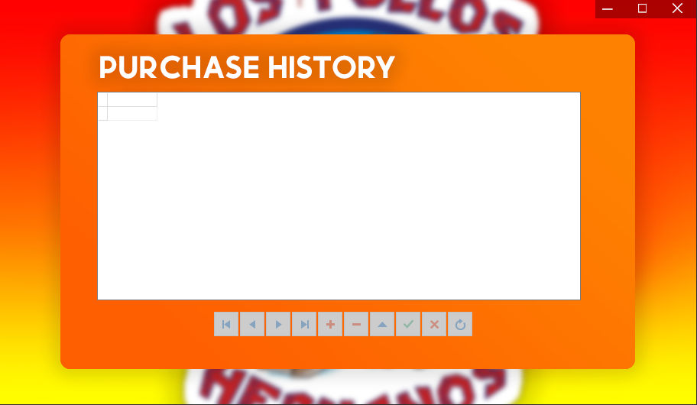

Figure 7 - Purchase history screen

# Database

## Tables, field types and field sizes

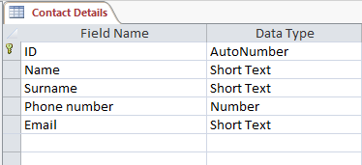

Table - Contact Details

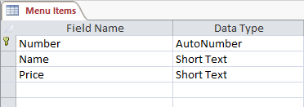

Table - Menu Items

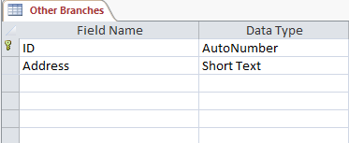

Table - Other Branches

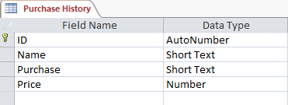

Table - Purchase History

# Data Dictionary

## Text Files

Will be used to make backups of the database and store large amounts of information and also be used to store the generated receipts.

## Arrays

Arrays will be used to store the users orders and transfer them into a database and they’ll be used for changing items in the database.

# IPO Table

|  |  |  |  |
| --- | --- | --- | --- |
| **Screens** | **Input** | **Process** | **Output** |
| ***Welcome screen*** | Source of input:   * Mouse click   Data type:   * N/A   Format of input:   * N/A   GUI component used:   * TImage   Errors   * N/A   Data to input   * N/A | Login screen form is displayed and the welcome screen is then hidden when the login button is clicked or user can bypass login by logging in as guest and use the kiosk in customer mode | Login form is displayed |
| ***Login screen*** | Source of input:   * Keyboard * Mouse click   Data type:   * String   Format of input:   * N/A   GUI component used:   * TImage * TEdit   Errors   * Message dialogue if login details are incorrect * Message dialogue if nothing is entered   Data to input   * Email * Password | User is required to enter their login details if correct they’ll be redirected to the home screen and the login screen will be hidden. If they are incorrect or they haven’t entered anything the appropriate message dialogue will be shown | Message dialogues for errors are displayed and the home screen form is displayed |
| ***Home screen*** | Source of input:   * Mouse click   Data type:   * N/A   Format of input:   * N/A   GUI component used:   * TImage * Radio buttons   Errors   * N/A   Data to input   * N/A | Main screen of the kiosk. It is the gateway to all the other screens in the kiosk.   1. User chooses which screen they would like to visit 2. That form will be displayed 3. Home screen form will be hidden | Chosen form is then displayed |
| ***Menu screen*** | Source of input:   * Mouse click   Data type:   * N/A   Format of input:   * N/A   GUI component used:   * TImage | Users will be presented with the menu, they will be able to choose which item they would like to order and they’ll be directed to the payment screen | User is presented with menu |
| ***Payment screen*** | Source of input:   * Mouse click * Keyboard   Data type:   * String   Format of input:   * N/A   GUI component used:   * TImage * TEdit   Errors   * Message dialogue if nothing is entered * Message dialogue if information entered is in wrong format   Data to input   * Payment type * Account details | User will have to choose a payment method then enter their relevant details. If users’ details are incorrect or they leave the fields blank an appropriate error will be displayed | A receipt is printed and saved in a text file |
| ***Contact us screen*** | Source of input:   * Mouse click   Data type:   * N/A   Format of input:   * N/A   GUI component used:   * TImage   Errors   * N/A   Data to input   * N/A | User will be presented with contact details for management when they hover their mouse over the relevant picture | Managers contact details will be shown |
| ***Purchase history screen*** | Source of input:   * Mouse click * Keyboard   Data type:   * Arrays * String   Format of input:   * N/A   GUI component used:   * TImage * TDBGrid   Errors   * N/A   Data to input   * N/A | If user has logged in with manager credentials they’ll be able to access the purchase history screen where they can view and edit a database of all purchases made with the kiosk. | All the purchases made via customers will be saved in the database and displayed here. Any changes made will also be saved into the database. |
| ***Restaurant screen*** | Source of input:   * Mouse click   Data type:   * N/A   Format of input:   * N/A   GUI component used:   * TImage * TEdit   Errors   * N/A   Data to input   * N/A | User will be able to search and view the address of restaurants saved on the database | The image and data of the restaurant searched will be displayed |
|  |  |  |  |
|  |  |  |  |